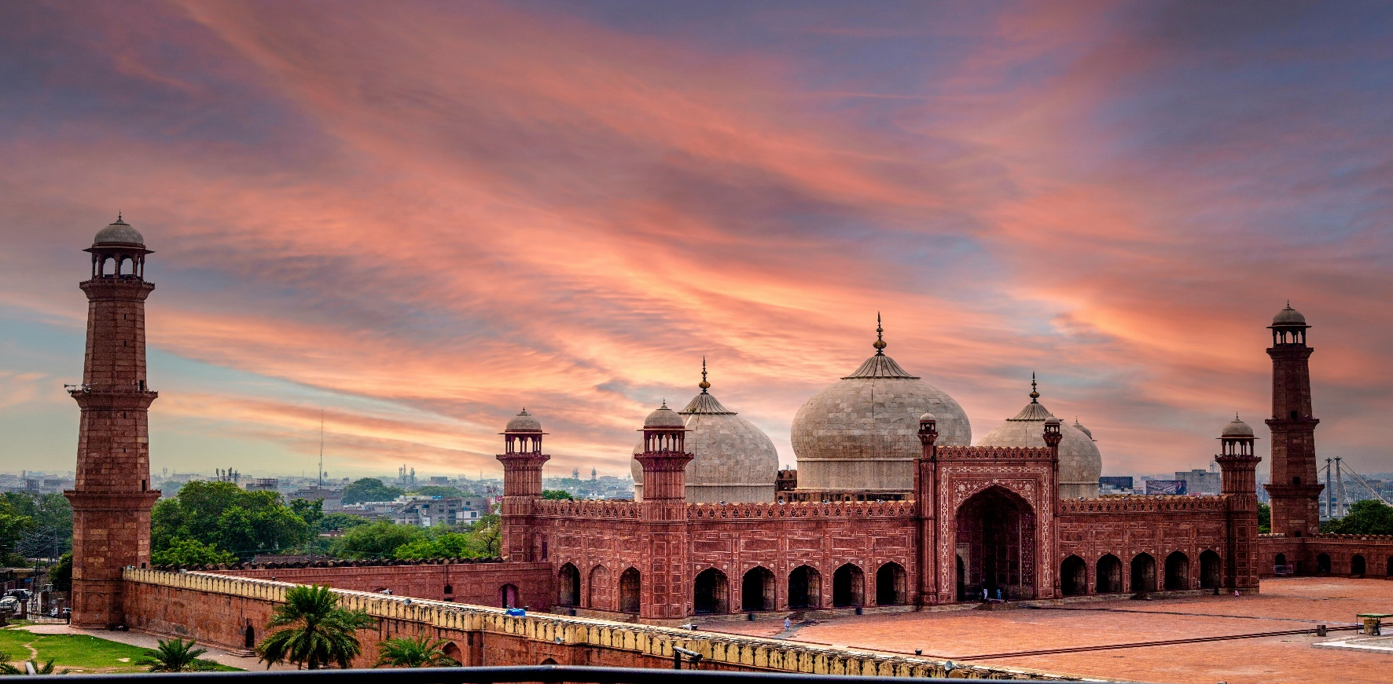

**BADSHAHI MASJID**

**A Timeless Marvel of Mughal Architecture**

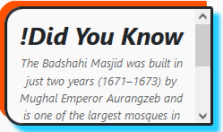The Badshahi Masjid, situated in the heart of Lahore, Pakistan, stands as an enduring symbol of Mughal grandeur and architectural brilliance. Constructed in 1673 under the reign of Emperor Aurangzeb, this majestic mosque is one of the largest and most iconic in the world. With its stunning red sandstone façade, intricate marble inlays, and awe-inspiring minarets, the Badshahi Masjid reflects the rich cultural and religious heritage of the Mughal Empire. Spanning an area capable of accommodating over 100,000 worshippers, the mosque’s vast courtyard and beautifully adorned prayer hall captivate the hearts of visitors and worshippers alike. As a testament to its historical significance, the Badshahi Masjid has not only served as a center of spirituality but also as a prominent tourist destination, drawing millions from around the globe to witness its magnificence. Whether you seek tranquility, history, or architectural inspiration, the Badshahi Masjid offers a timeless journey through centuries of craftsmanship and devotion.

# The Jewel of Lahore’s Cultural Landscape

Nestled near the iconic Lahore Fort, the Badshahi Masjid is a masterpiece of Mughal

artistry and an integral part of Pakistan’s cultural heritage. Completed in the late 17th century, this grand mosque was commissioned by Emperor Aurangzeb, showcasing his vision of Islamic architecture at its zenith. The mosque’s imposing structure, crafted from red sandstone with intricate white marble embellishments, stands as a testament to the opulence and skill of the Mughal era. Its harmonious blend of geometric precision, floral motifs, and Quranic inscriptions create an atmosphere of serenity and spiritual connection. The Badshahi Masjid’s location amidst Lahore’s vibrant historical quarter makes it a focal point for both cultural exploration and religious devotion. Visitors can marvel at its towering minarets, expansive courtyards, and the breathtaking view of the Ravi River, making it an unforgettable experience. Recognized globally as a symbol of Islamic architecture, the mosque continues to inspire awe and reverence in all who visit.

**A Monument of Faith and Heritage**

The Badshahi Masjid is more than just a mosque; it is a living testament to the grandeur and legacy of the Mughal Empire. Located in the historic city of Lahore, this architectural gem was completed in 1673 under the patronage of Emperor Aurangzeb Alamgir. Its awe-inspiring design, featuring massive domes, towering minarets, and a sprawling courtyard, reflects the Islamic ideals of symmetry, balance, and grandeur. The mosque’s interior is equally captivating, adorned with delicate frescoes, calligraphy, and intricate floral patterns that evoke a sense of divine beauty. As one of the largest mosques in the world, the Badshahi Masjid has been a place of worship, a center for learning, and a source of inspiration for centuries. Beyond its religious significance, the mosque stands as a cultural landmark, attracting historians, architects, and travelers who come to admire its unparalleled artistry and historical importance. For those visiting Lahore, a trip to the Badshahi Masjid is a journey into the soul of Islamic architecture and Mughal history.

**Badshahi Masjid: A Symbol of Spiritual Grandeur**

The Badshahi Masjid, also known as the “King’s Mosque,” is an architectural masterpiece that embodies the spiritual and artistic zenith of the Mughal Empire. Situated in Lahore, it was commissioned by Emperor Aurangzeb in 1671 and completed in 1673, reflecting the Mughal’s unparalleled dedication to beauty and faith. The mosque’s immense red sandstone structure, accented with pristine white marble, creates a striking visual impact that leaves visitors in awe. Its grand courtyard, capable of hosting thousands of worshippers, and its ornately decorated interiors evoke a sense of divine presence and peace. The Badshahi Masjid’s historical and cultural significance extends beyond its architectural brilliance. It has witnessed centuries of prayers, celebrations, and historical events, making it a cherished symbol of Islamic heritage. For modern visitors, the mosque offers not only a glimpse into the artistic genius of the Mughal era but also a serene space for reflection and spiritual connection. Whether viewed as a historical treasure or a place of worship, the Badshahi Masjid continues to inspire and captivate all who encounter its timeless beauty.

# ENJOYABLE ACTIVITIES

# 

! Experience the tranquility of the mosque’s vast courtyard and beautifully adorned prayer hall, offering a serene escape from the city’s hustle and bustle.

! Enjoy breathtaking views of the Lahore Fort and the city skyline from the mosque's elevated platform and iconic minarets.

! Marvel at the stunning red sandstone structure, intricate marble inlays, and towering minarets that showcase the timeless craftsmanship of the Mughal Empire.

**An Architectural and Spiritual Marv el**

The Badshahi Masjid, or "King’s Mosque," is a monumental testament to the grandeur of the Mughal Empire and its profound cultural and religious legacy. Located in Lahore, Pakistan, this iconic mosque was constructed by Emperor Aurangzeb in 1673, embodying the pinnacle of Mughal architectural excellence. Spanning an area that can accommodate over 100,000 worshippers, it is among the largest mosques in the world and a beacon of Islamic spirituality. The mosque’s design is a harmonious blend of red sandstone and white marble, featuring grand arches, massive domes, and intricately decorated interiors that showcase exquisite frescoes, calligraphy, and floral motifs. Its symmetrical layout and the serene ambiance of its vast courtyard evoke a sense of divine majesty and peace. Over centuries, the Badshahi Masjid has served not only as a place of worship but also as a cultural and historical landmark, attracting countless visitors who seek to marvel at its unparalleled beauty and delve into its rich history. A visit to the Badshahi Masjid is not merely an exploration of an architectural masterpiece; it is an immersion into a timeless legacy of faith, art, and history.

**A Legacy of Faith and Craftsmanship**

The Badshahi Masjid stands as a majestic emblem of the Mughal Empire’s devotion to faith and artistic brilliance. Completed in 1673 under the patronage of Emperor Aurangzeb, this mosque in Lahore, Pakistan, is a striking example of Islamic architecture and one of the largest mosques in the world. Its imposing structure, built with red sandstone and adorned with white marble accents, is a marvel of engineering and design. The mosque’s grand courtyard, colossal minarets, and intricately crafted prayer hall reflect the Mughal emphasis on symmetry, precision, and elegance. Inside, the richly decorated walls and ceilings feature masterful calligraphy and intricate patterns that narrate the beauty of Islamic art. Beyond its architectural splendor, the Badshahi Masjid is a symbol of spiritual significance, hosting countless prayers, religious gatherings, and moments of reflection over centuries. Situated near the Lahore Fort, it forms a key part of Lahore’s historical and cultural landscape, drawing millions of visitors annually. Whether admired for its artistic craftsmanship or cherished as a place of devotion, the Badshahi Masjid remains an enduring icon of heritage and spirituality.

# LOCATION

Badshahi Masjid is located in Lahore, Punjab, Pakistan, right next to the Lahore Fort. Built during the Mughal era in the 17th century, it stands as one of the largest mosques in the world and is a stunning example of Mughal architecture.

# Why Visit Badshahi Masjid?

**The Badshahi Masjid is a stunning Mughal-era masterpiece, known for its grand architecture, rich history, and spiritual ambiance. As one of the largest mosques in the world, it’s a must-visit landmark in Lahore, offering an unforgettable glimpse into Islamic heritage.**

# Logo FEATURED PRODUCT